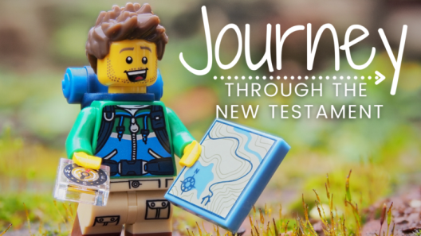
Welcome ~ June 6th
This Week at Cornerstone:
Today - | Worship Practice & Set-Up . . . . . . . . . . . . . . | 7:45 AM
 | Worship Service . . . . . . . . . . . . . . . . . . . . . . . | 9:00 AM
 | Church Brunch . . . . . . . . . . . . . . . . . . . . . . . . . | 11 AM
Wednesday - | Zoom prayer . . . . . . . . . . . . . . . . . . . . . . . . . . | Noon
Sunday - | Worship Practice & Set-Up . . . . . . . . . . . . . . | 7:45 AM
 | Worship Service . . . . . . . . . . . . . . . . . . . . . . . | 9:00 AM

Nursery (available for infants through preschool)

This Week: Phyllis & AJ

Next Week: Alicia & Joanna

Coming up…
Home Groups
Home groups will be taking a break for the month of June. Take this time to connect with those at church and those in your community!
Home Groups will be back July & August.

BRUNCH – Today
Join us celebrating all the years Brian & Sarah Brunsell
have served with us at Cornerstone.
There will be plenty of food!

Baptism coming this summer!
We will be having a baptism service one Sunday this summer. Let Pastor Nate know if you are considering being baptized.

COVID restrictions
All COVID restrictions will be lifted beginning next Sunday.
You are welcome to continue wearing a mask and social distancing,
but those decisions will be up to you. Thank you for your patience through this challenging season!

ANTICIPATING ETERNITY

2 Corinthians 5:1-10

What is one thing you’re looking forward to this summer?

What does Paul “fix his eyes on” that might help us too?
- What’s the difference between our ____________________________ and our ____________________.

- What will it be like to be in the ________________________________ of God?

What does Paul conclude?
- There are ___________________________________. V6

- _________________________ some of the most profound realities that exist. V7

- ________________________________ is better than anything else this world can offer. V8

- My #1 priority is to ____________________ in this life (and the next). V9

- After this life, we will __________________________. V10

How will I respond?
- ______________ to live by faith. V7
- _____________________ to what God promised is coming. V8
- ___________________________ to please God in this life. V9
- Realize that what I do in this life ______________________________. V10

Next Week: “Journey through the New Testament” series continues
“Painful Love & Generous Giving ~ 2 Corinthians 7-9

I’m praising God for… ________________________________________________________________________________________________________________

Please PRAY for me…
________________________________________________________________________________________________________________
- For Pastors’ eyes (Nate & Brian)
- For the CCC prayer team
I am interested in…

- Home Groups
- Knowing the Bible better
- Oasis Youth Center
- Children’s Ministry
- Music Team
- Prayer Team
- Setup Crew
- Counseling

Please tear off this portion
of your program and drop it
in the offering box before
you leave today.
Thank you!
Pastor Nate

